Research on Self-Directed Informal Learners in Open Educational Environments and Massively Open Online Courses

Curtis J. Bonk, Indiana University

Mimi Miyoung Lee, University of Houston

Feng-Ru Sheu, National Sun Yat-Sen University, Kaohsiung City, Taiwan,

Xiaojing Kou, Indiana University

Abstract
There are an endless array of open educational resources and other online contents available for self-directed learning pursuits. This study explores the informal learning experiences, including the barriers, obstacles, motivations, and successes of directed online learners. Data collection included a 43-item survey of 159 participants enrolled in a massive open online course (MOOC) hosted by Blackboard using CourseSites. Of those respondents, 49 completed the 15 open ended survey items. As a mixed methods design, the researchers qualitatively analyzed emerging themes from open-ended survey items as well as the descriptive statistics from the closed-ended items. The findings help capture informal and self-directed learning preferences, achievements, supports, and experiences through informal education channels. Across the data, it is clear that self-directed online learners are internally motivated and appreciate the freedom to learn and choice that open educational resources provide.

Research on Self-Directed Informal Learners in Open Educational Environments and Massively Open Online Courses

We are in the midst of an incredible array of changes in both K-12 and higher education today that would have been unthinkable just a decade or two ago. People in remote parts of the world are learning from well-known professors at Princeton, Rice, Harvard, and MIT; typically, without a fee. Countless millions of individuals are engaged in self-directed, informal, and solitary learning experiences, while myriad others are highly engaging collaboratively learning with global peers who have signed up for the same course or experience.
As these learning experiments unfold, many aspects of the college experience are being called into question. There is debate about the value or even the need for a degree. According to Luke (2013), some corporate settings are bypassing traditional degrees as the sole determiner of ability and are beginning to find people who are self-determined to learn the corporate culture and work through nontraditional or informal learning on their own. Creativity and initiative are emphasized over following rules. Luke suggests that human resource departments seek job candidates who have a dual approach to development, combing degrees programs with self-education. Self-education may result in certificates, badges, or other credentials that may or may not be reflected on one’s resume. As a result of unclear rules on how to represent skills and competencies acquired through informal learning experiences, organizations and institutions need to find new ways to ascertain the skills learned from such pursuits.
In the midst of these changes, Friedman (2013) suggests that the revolution that he announced for the business world with his infamous book, “The World is Flat” (Friedman, 2005), has now migrated to higher education. In responding to Friedman’s ideas, Waks (in press), in his upcoming book, Education 2.0: The Learningweb Revolution and the Transformation of the School,” offers a conceptual model to make sense of the possibilities. The factory model of education is being replaced by networked approaches. Waks points out that collaborative technologies, open access textbooks, e-books, learning repositories, social networking technology, Web conferencing, and open educational resources (OER) are enabling greater opportunities for learner self-determined or self-directed learning.
While a plethora of changes have rapidly coalesced, they have not transpired overnight. Detailed below are a few key trends and historical markers for this educational movement toward more free and open content.

The Rise of Massive Open Online Courses (MOOCs)
The evolution of OER and OpenCourseWare (Vest 2001), and online learning in general has led to the creation of massive open online courses (MOOCs). MOOCs illustrate the fact that we have entered an age of information abundance instead of information scarcity (Kop, Fournier, & Mak, 2011). Taking advantage of such resources, thousands, or even tens or hundreds of thousands of people around the world often enroll in a single MOOC experience such as one on social networking technology, sustainable health diets, introductory chemistry, or artificial intelligence (Bowman, 2012).
Research from Rita Kop and her colleagues (Kop et al., 2011) documented that is it possible for a MOOC to provide more than traditional course information and assignments. MOOCs, in fact, can support the building of connections between those seeking to learn something and course facilitators as well as among the learners in a rich community of learners. When designed to harness information flows within networks of people, exciting and spontaneous learning can result. Individuals in a MOOC are often sharing and adding to the course resource pools, negotiating and communicating ideas, collaborating with peers, and coaching and mentoring others. Such MOOCs illustrate concepts and principles related to the new learning theory called connectivism (Downes, 2012) and have been branded as “cMOOCs” (Morrison, 2013). The first MOOC was offered by George Siemens of Athabasca University and Stephen Downes of the Canadian Research Council in 2008 (Downes, 2012). It was a cMOOC.
It was not until three years later that MOOCs received national and international attention. In the fall of 2011, a series of MOOCs from Stanford each enrolled more than 100,000 participants (Beckett, 2011; Markoff, 2011). These were dubbed xMOOCs since they were taught in a similar fashion to campus-based lecture courses (Morrison, 2013). Due to the size of the enrollments, MOOCs have drawn much media and government attention. World leaders such as Bill Gates are intrigued by their ability to expand educational opportunities at a low cost (Young, 2012a).
After those courses at Stanford showed a proof of concept, several companies have emerged to offer MOOCs including Udacity, edX, Coursera, and NovoEd. These entities are quickly forming partnerships with top tier higher education institutions. Laura Pappano of the New York Times, in fact, declared 2012 to be “The Year of the MOOC” (Pappano, 2012). In her special review of MOOCs, thorny issues related to grading, feedback, quality, cheating, retention, and learner background present problems for those offering MOOCs. Such issues will only increase given that most institutions have not yet offered a MOOC or even created a strategic plan for them (Allen & Seaman, 2013). In fact, research from Allen and Seaman indicates that a large percentage of university administrators are currently planning for a MOOC in the near future.
As suggested by the name, MOOCs are typically free and open. Nevertheless, there are an assortment of revenue models emerging (Kolowich, 2013; Young, 2012b). A couple of those revenue generating ideas entail requiring those who enroll to pay for optional assessments or certificates at the end of a MOOC or paying a modest entry or enrollment fee. Other business plans include free courses with paid advertising, selling student data (especially that related to high performing students), and having the first course in a degree program to be a free MOOC. ALISON, for instance, offers free online courses for basic workplace skills (e.g., financial and economic literacy, business and enterprise skills, introduction to banking, career planning, etc.) paid through advertisements (Bornstein, 2012). World Education University is using a similar advertisement-based model.
Among the key issues of MOOCs is participant retention and motivation. A recent study of a MOOC at Duke University in the area of bioelectricity as well as a set of six MOOCs at the University of Edinburgh (e.g., critical thinking, introduction to philosophy, equine nutrition, AI planning, astrobiology, e-learning and digital cultures) indicate that the retention rate in a MOOC is often quite low (Catropa, 2013; MOOCs @ Edinburgh, 2013). In the Edinburgh study, participants signed up for various reasons including to learn about the subject matter, try online education, experience a MOOC, browse the course, obtain a certificate, improve career prospects, and become part of a learning community. More insights are needed about the motivational aspects of MOOCs as well as how to increase the percentage of those venturing beyond the first week of a MOOC experience and perhaps even completing it.

The Need for Self-directed Learning
As is clear from this brief review of the literature on the world of open education and MOOCs, informal learning resources and tools are proliferating online (Bonk, 2009). As a result, learning is becomes increasingly informal and self-directed or self-selected (Cross, 2007). This trend is pervasive across all age levels and occupations. For instance, some young people are skipping K-12 school settings and instead studying from OER (Al Haddad, 2011). Other youth who lack decent textbooks or where teachers are in short supply, such as young children in India, are learning from free videos provided by the Khan Academy (Chandrasekaran, 2012). At the same time, adolescents like 16 year old Timothy Donner are learning multiple languages through free online resources (Leland, 2012). As a teenage polyglot, Donner knows Yiddish, Russian, Persian, Swahili, Dutch, Hindi, German, and many other languages.
The importance of self-directed learning (SDL) has been noted for decades (Deci & Ryan, 2008; Ryan & Deci, 2000). In recapping the literature on SDL, Abdullah (2001) noted that those who are self-directed learners tend to be highly curious, view problems as challenges, desire change, and are willing to try new things. They are also persistent, self-disciplined, goal oriented, independent, self-confident, and generally enjoy learning. As she puts it, they are “responsible owners and managers of their own learning.” Such individuals are highly attuned to the importance of making learning meaningful and relevant. Finally, and perhaps, most importantly, they also self-monitor, evaluate, and regulate one’s learning.
From this perspective, learners need opportunities to learn and a sense that they are free to learn when and where they feel the need (Reeve, 1996). According to Rogers (1983), learning should always be highly active and open, involve genuine tasks, and respect the background and ideas of all learners. Simply put, learning should be learner-driven and filled with opportunities for learners to make decision and take responsibility for their own learning. The more that learners can freely and openly explore learning experiences, the greater the chance that they will exhibit their creativity and participate in productive ways in the world at large (Rogers, 1969).
In effect, there is a need for learner choice and volition in the material that is selected and in the tasks in which they express their learning gains. Learner volition and inner will or purposeful striving toward some action or learning goal is at the crux or heart of self-directed learning pursuits. In recapping the literature on intrinsic motivation, Pink (2009) makes the claim that this internal drive system is focused on getting better at something that is personally meaningful or relevant; in essence, it matters.
In many ways, distance learning on the Web is the ideal platform for testing theories related to intrinsic and self-directed learning (SDL). For many of the pioneers of distance learning research, television, correspondence, and satellite learning were ideal learning formats for learners who were self-motivated (Wedemeyer, 1981). Building on decades of such learning formats, Garrison (1997) from the University of Calgary designed a comprehensive SDL model with three interacting dimensions; namely, (1) self-management, (2) self-monitoring, and (3) motivation. He pointed out that SDL is successful when learners can take control of the learning context to reach their personal learning objectives (Song & Hill, 2007). To attain to their goals, they must effectively manage the learning resources that are provided; often with little or no guidance. Of course, as learning online from OCW, OER, and MOOCs shifts control of the learning environment toward the learner, there are myriad problems, challenges, and opportunities for learners related to effective resource use. The barriers or challenges of many SDL environments include less immediate feedback and guidance, impersonalization, procrastination, and becoming overwhelmed by the resources made available (Graham, 2006).
Given these issues, it is not too surprising that the recent emergence of online learning and OER has reawakened interest in the field of self-directed learning (Hyland & Kranzow, 2011). Adults, in particular, are being pressured to keep their knowledge and skills up-to-date in order handle fast changing work requirements. As a result, lifelong learning and self-directed learning have risen in importance (Lin, 2008). However, there are relatively few studies of the experiences of self-directed online learners as they move through non-formal learning channels. Therefore, it is vital for researchers to explore the potential of more free and open learning materials and resources and what learners encounter as they explore them. In particular, there is a pressing need to better understand the goals and aspirations as well as the obstacles and barriers to success in non-formal learning channels/environments by the people learning from open educational contents and courses such as MOOCs.
The purpose of this study is to investigate self-directed online learning pursuits of participants of a MOOC. As educators and instructional designers better understand success stories as well as the challenges and obstacles of non-formal learning with OER and emerging learning technology, they can design and develop enhanced online learning contents and supports. In addition, documented life changes from OER can also serve as catalysts and benchmarks for others to try out such resources.

Research Methodology

Web-Based Survey Construction
A list of over 300 informal and extreme learning websites was created by a team of researchers based on a thorough literature review as well as recommendations from soliciting expert recommendations, blog post reviews, and scanning other online resources. These Web resources included those related to language learning, adventure learning, social change/global education, virtual education, learning portals, and shared online video. After spending a year evaluating these Websites (Jung, Kim, Wang, & Bonk, 2011), a 43-item survey questionnaire was designed using SurveyShare, a Web-based survey hosting service. The survey was intended to understand self-directed learning from such free and open online environments; including the collection of life changing stories.
The close-ended portion of the survey inquired into many aspects of informal online learning. Such areas included the goals one wished to accomplish through informal learning pursuits and activities on the Web (e.g., new friends, personal freedom, etc.), reasons for exploring Web resources informally (e.g., curiosity, interest, professional growth, etc.), factors leading to success (e.g., choice, advice from others, producing or creating something, etc.), what they would like to learn (e.g., a foreign language, artistic skills, environmental information, music skills, etc.), and typical barriers or obstacles faced when learning informally on the Web (e.g., lack of time, technical problems, lack of quality resources, etc.). We also asked more general questions about what they would like to achieve (e.g., learn how to fix something, course credit, learn something that can be used to help others, etc.).
In addition to those 25 close-ended questions, respondents had the option to complete 15 open-ended questions that asked about their informal learning experience (See Appendix A for details on the “Open Ended Survey Questions”). Among them were questions related to respondent goals and aspirations using OER, OCW, and MOOCs. Participants were also asked about their most interesting and successful informal learning experiences and what they accomplished. Another open-ended item concerned advice or suggestions for others wanting to learn informally with OER, OCW, and other Web resources and technologies. Still other open-ended items included those related to the informal learning influences and supports that they received (e.g., colleagues, mentors, friends, etc.). Finally, we inquired into the challenges and obstacles that informal learners face when using online educational resources.

Population

A massive open online course (MOOC) on “Instructional Ideas and Technology Tools for Online Success” was taught from late April to early June in 2012. It was hosted by the e-learning company, Blackboard, using their free course management system called CourseSites. Shortly after the course ended, a link to the 43-item Web-based survey was sent out to 3,800 participants of the MOOC. The survey took approximately 15 to 20 minutes to complete. As a mixed methods study, open-ended survey findings are supplemented by several quantitative results.

There were 159 completed surveys from the Blackboard MOOC participants, including 49 who completed the optional open-ended items. The majority of the survey respondents were female (73%) and were from North America (81%). In addition, 72% were over 40 years old. It should also be noted that a large percentage of the respondents in this subject pool were college instructors who signed up for the MOOC as a means of enhancing their skills in teaching online. They found out about the MOOC through press releases from Blackboard as well as from an email message sent to users of CourseSites.

Quantitative Survey Findings
Respondents were asked about the places in which they learned informally as well as the devices in which they used for such endeavors. The MOOC respondents typically used a laptop (89 percent) or desktop (75 percent) to access informal learning resources. A majority also used a smartphone (67 percent) or tablet computer (52 percent). At the same, many of these individuals used devices such as e-book readers (39 percent), iPods (28 percent), car CD/DVDs (26 percent), or TV with Internet (15 percent) to informally learn online (see Figure 1). Clearly, while traditional desktop and laptop computing are the most common informal learning access points, there are myriad delivery mechanisms for engaging in informal learning today. Most respondents, for instance, also utilized smartphones as well as tablet computers and nearly 4 in 10 had an e-book reader. Such devices extend the possibilities for self-directed informal learning to all aspects of one’s life.

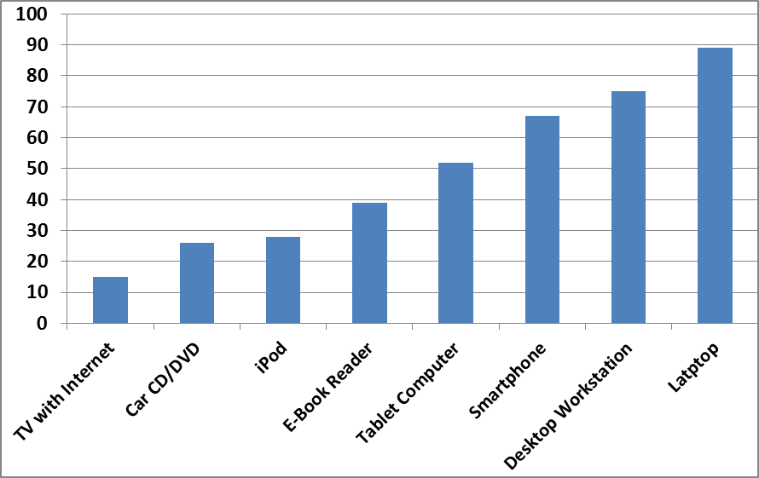
Figure 1. Devices used to learn informally with technology

It was also deemed important to know where people are often located when using such devices. Home (89 percent), work (73 percent), school or university (61 percent), or anywhere with a mobile device (56 percent) were among the popular places for accessing informal learning resources and materials (see Figure 2). Other common locations included a café or bookstore (38 percent), car, truck, or bus (33 percent), library (32 percent), and subway or train (15 percent). Respondents were also engaged in such activities when hiking, walking, or jogging (11 percent), attending sporting or entertainment events (8 percent), and when on a boat or out at sea (6 percent). As the earlier questions about delivery vehicles for informal learning indicated, it seems that learning is occurring in all aspects of one’s life. Stated another way, mobile computing devices and wireless connections to the Internet are vital aspects of informal learning today.

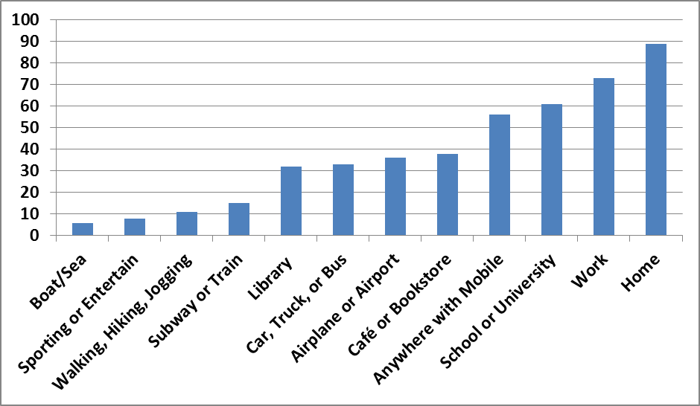
Figure 2. Places respondents engage in informal learning with technology

While understanding the devices and locations for informal learning is informative, it is also vital to grasp the purposes and goals when attempting to learn informally with technology. The vast majority of our survey respondents simply wanted to acquire a new skill or competency (85 percent). At the same time, many hoped to learn something that they could use to help others (65 percent) or society in general (37 percent). Nearly half of the respondents indicated that they desired to acquire cultural knowledge (45 percent), teamwork or collaboration skills (44 percent), or something to better their lives (44 percent). Four in ten respondents explore resources on the Web in order to learn how to fix something. A smaller percent were there to engage in a game or learning quest (21 percent). Ironically, only one-third were learning informally in hopes of course credit and even fewer were in completing courses or modules that did not count for a degree (27 percent). What is clear is that respondents learn informally online with specific skills in mind, not the eventual completion of a course or degree program. Humanitarian and personal reasons outweigh academic ones.
Respondents were then asked about specific skills in which they would like to learn informally online. As shown in Figure 3, roughly half were seeking language skills or cultural information. Nearly 4 in 10 respondents often were hoping to gain health-related or global information. Also important was historical information (36 percent), environmental information (27 percent), science skills (25 percent), vocabulary (23 percent), artistic skills (23 percent), and mathematical skills (19 percent). Interestingly, far fewer were looking to gain outdoor, music, or athletic skills.

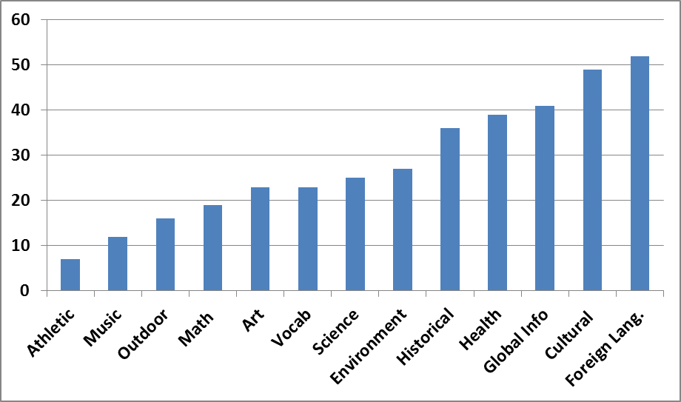
Figure 3. Specific skills wanting to learn informally online

As shown in Figure 4, there are many intrinsically motivating factors involved in informal learning online. Survey respondents found that interest in the topic to be vital (see Figure 4). Most also selected professional growth needs, curiosity, a personal need for information, goals for self-improvement, and choice or freedom in the selection of topics or resources to explore as the main reasons for accessing informal online learning resources and Websites. Other motivational factors included wanting to learn something new, feelings of personal control over one’s own learning, and finding that a Website or activity looks exciting. Somewhat surprisingly, just one in ten were exploring the Web as part of their hobbies.
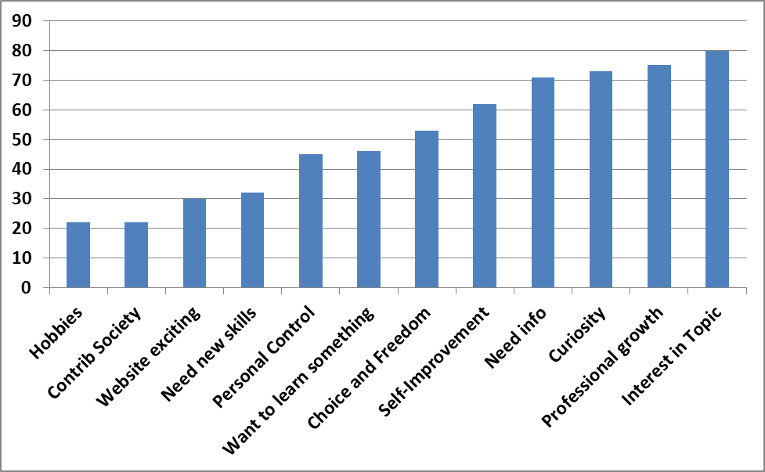
Figure 4. Main reasons to informally explore the Web to learn

It was deemed important to ask what people typically accomplished when in informal online environments. Fortunately, as displayed in Figure 5, most respondents realized their goal of learning something new (84 percent). Half of them felt better about themselves as learners. Many even changed their beliefs about what learning is (39 percent), while one in four had a better feeling about themselves as human beings. A sense of personal freedom was noted by 35 percent of the respondents. Around 30 percent deemed keeping up with their friends to be a major achievement while 20 percent said the same about keeping up with family members. Importantly, slightly more than one in five got a new job from their informal learning experiences. A similar percentage discovered a new occupational or career interest, while slightly less (16 percent) were promoted in their work setting. In addition, one in four had received a certificate of some type. Based on such responses, there is no doubt that informal online learning is changing the lives of many people. Some aspects of these findings related to informal learning achievements are further elaborated on in the qualitative data section.
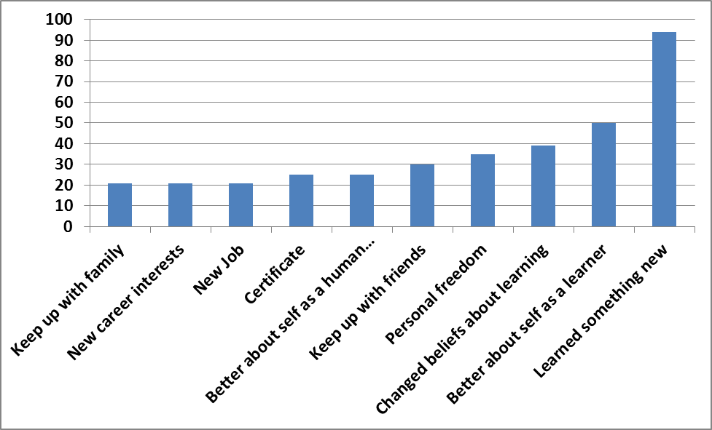
Figure 5. Achievements from learning informally online

When these individuals were asked to rate the impact of informal Web-based experiences on their lives, that vast majority were highly positive. In fact, on a scale of 0 (i.e., “No Impact”) 5 (“Some Positive Impact”) to 10 (“Significant Positive Impact”), only 5 percent of the respondents were indicated a rating of under 5. In fact, 1 in 5 respondents marked 10 and nearly 80 percent indicated a 7 or higher in terms of impact. Apparently, informal learning leaves an indelible mark on one’s life.
Experiencing high levels of achievement or success in informal online learning is vital, but it is also important to understand the factors that lead to those successes and failures. Figure 6 provides a visual overview of some of the key ones. As would have been predicted by psychologist, Carl Rogers (1969), freedom to learn was rated the highest (61 percent), followed by having an opportunity to create or produce something (52 percent), a sense of resource abundance (47 percent), collaboration (44 percent), control over the activity or resource (41 percent), choice (38 percent), and a sense of fun (38 percent). Opportunities to share ideas, feel some sense of adventure, advice from others, novelty of the technology, and system feedback were also important. What these results signal is that informal learners want the freedom to pick and choose what they want to learn. When the resource pool increases, so, too, do the choices and opportunities for learner autonomy.

F 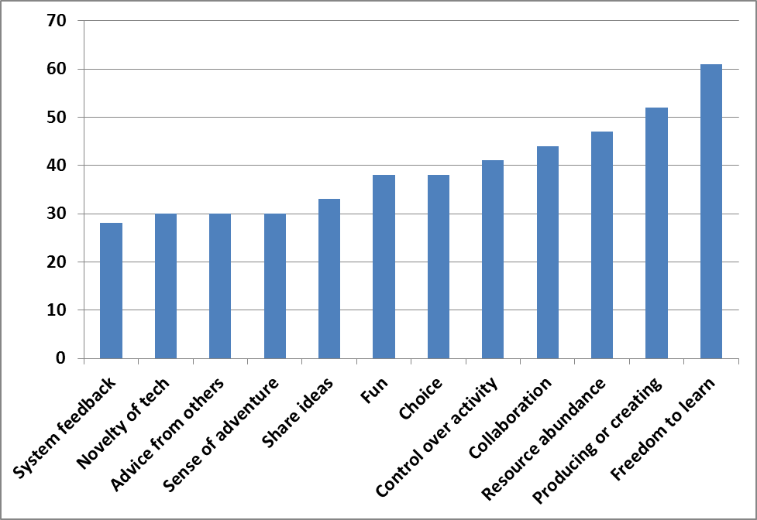Figure 6. Factors leading to success or personal change what learning informally online

Any achievement from self-directed learning often requires some form of support or guidance. Consequently, one survey question inquired as to the supports for their informal learning on the Web. More than sixty percent of the survey respondents relied on friends or colleagues, whereas twenty percent relied on their teachers or instructors. Relatively few relied on counselors or advisors (3 percent), family members (11 percent), or tutors or mentors (11 percent). Instead of family members or tutors, nearly one-third utilized experts and one-fourth trusted upon people that they never met. In effect, many respondents felt comfortable seeking out external experts or people that they never met.
The respondents answered similarly when they were asked how they find out about new or interesting informal resources on the Web to learn from. More than seventy-five percent simply browsed the Web on their own. The next most information sources were email, e-newsletters, and online news or announcements. After that, respondents relied on their friends and colleagues or blogs or podcasts to which they subscribed. Social networking sites like Facebook, Twitter, and Google Hangouts were also popular. Evidently, learners no longer rely solely on printed news, books, and magazines or instructors for their learning. Such information sources remain important but were far down the list of the preferred options.
We were not only interested in informal learning successes, but also obstacles and challenges that respondents faced in their self-directed learning pursuits. Of the four key problems or challenges salient in Figure 7, the most significant, not unexpectedly, was a lack of time for informal online learning (64 percent). Another obstacle was the fact that some informal learning resources and tools have associated technology or membership fees (39 percent). And if they are free, they may be difficult to use (27 percent). Fourth, some high quality informal learning resources are simply difficult for people to locate (27 percent). Less significant issues related to technology requirements embedded in the use of informal learning resources, support issues, website accessibility, and self-motivation or interest to use.

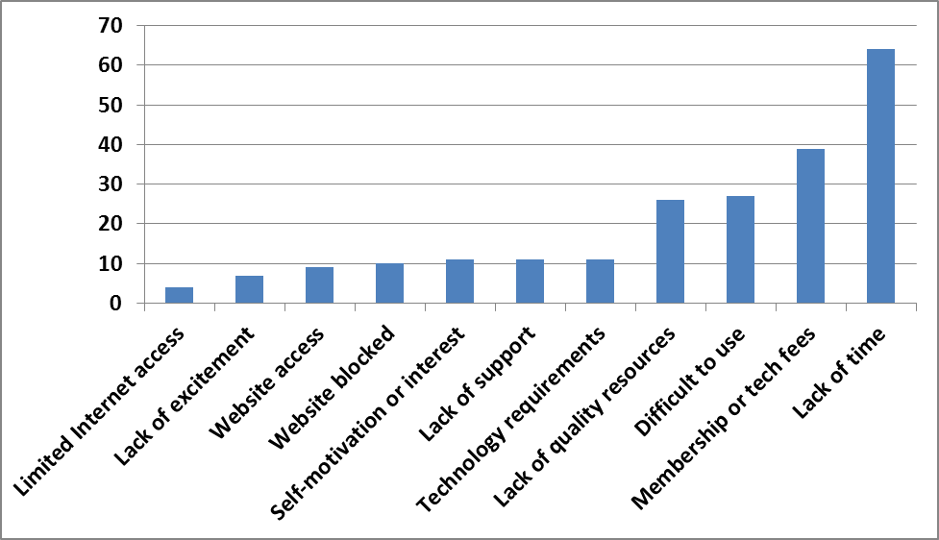
Figure 7. Obstacles and challenges faced when learning informally online.

Naturally, many of the quantitative findings discussed above were further explained or clarified in the qualitative results discussed below.

Qualitative Findings: MOOC Participants

The qualitative data from relevant open-ended questions was analyzed by a team of qualitative researchers. Team members coded the data for themes and comparisons across such themes. Where appropriate, the qualitative findings detailed below supplemented the quantitative findings from the close-ended items already discussed.
Not too surprisingly, when these Blackboard MOOC participants asked about their most interesting or successful informal learning experience, many of them focused on their recent MOOC experience. Others discussed prior professional development experiences (e.g., learning a new screencasting software tool, finding resources for stories of indigenous populations of Australia for one’s class, etc.). Some detailed their hobbies and personal interests (e.g., learning Korean language from podcast shows while bike riding, finding an interesting new recipe, locating information for sightseeing during a conference in New Orleans, watching TED talks on climate change or neuroscience, etc.). Others mentioned additional online courses or MOOCs that they had taken or were in the midst of. As a result, these findings do not relate strictly to MOOCs though responses related to the Blackboard MOOC experience clearly filtered through many of their open-ended responses.
In terms of the purpose or goals from their most interesting informal online learning activity, there were many motivators. Among our preliminary findings were five key motivators or goals for the respondents; namely, they wanted: (1) to improve their job prospects; (2) to pursue personal interests or hobbies; (3) certification of some type; (4) information or resources; and (5) to find ways to expand upon their formal learning. While these goals were quite diverse, each relates to finding a way to improve one’s competencies or life situation.
In terms of information seeking, many participants see the Web as a means of self-reliance. As one respondent noted, she and her husband were DIYers. “Today, we were trying to install a pool filter--we got instructions off You Tube. I also just bought a recumbent exercise bike--I looked at online reviews before making a choice. She then added, “Knowing that I did not need to ask an actual person for help was life changing. I am an introvert by nature, and I prefer to figure things on my own. Knowing that I can research informally on the Web is reassuring.”
As displayed in the above quote, there is also increased confidence and pride when one can be self-directed in learning. Similarly, another respondent noted, “I don't know if you consider this formal or informal but it has been something I have accomplished on my own. It has been empowering and rewarding to become a research detective online.”
Several traits or characteristics about those learning informally online emerged from the data. First, many felt a strong degree of intrinsic motivation and prided themselves for being a self-directed learner. As part of this, they emphasized the aspect of informal learning that was most valuable; namely, “my own pleasure” or passion. Such individuals valued their learning autonomy and considered it highly empowering. As one person stated, “I continue to research my interests for my own pleasure, especially on sites like Amazon for books and e-books, and have ongoing email alerts for journal content. I also use online sources for job hunting and professional networking.”
Another stated, “Knowing that I did not need to ask an actual person for help was life changing. I am an introvert by nature, and I prefer to figure out things on my own. Knowing that I can research informally on the Web is reassuring.” In effect, informal learning from OER can increase confidence and enhance one’s sense of self-efficacy as a learner.
Another trait of these informal learners was that they considered sharing to be an important part of the educational process. A third trait was their personal pride in creating or contributing something to the MOOC or informal learning resource that others could use. That is to be expected since, as noted in the literature review, self-directed learning often leads to exploration and creative outcomes (Lin, 2008; Waks, in press). However, it is a balancing act. As one person argued, when credentials like badges are added, they take away from the fun and enjoyment. It turns a playful pursuit of learning into a competition.
Just play around with ideas for alternatives to printed texts and don't be afraid to create your own, even if they're amateurish. Perhaps people who are experimenting can get together in groups: as writers people (including me) don't seek out readers enough and that will also apply to people experimenting with alternative modes. I think we need to de-emphasise formal assessment and accreditation and encourage our playful side to see what is possible. Too much informal learning wants to get itself 'badged' or validated too quickly and this means its losing its genuine amateur status.
In contrast, another respondent who successfully completed two workshops of Wiki Educator and learned many new skills about wikis found herself, “highly motivated to do all I could and learn as much as possible.” This respondent also stated that the “certification scheme in the wiki workshop was also very motivating, and I achieved Wiki Apprentice 2 level so far.”
A fourth characteristic of these self-directed learning respondents was that they enjoyed meeting people with similar interests in an online community, though they would not necessarily enjoy face-to-face (FTF) interaction with these same people. There apparently is some psychological safety from realizing that the expert resources are available online when needed but that you do not have to personally meet or know the individuals who are helping you out.
So to recap, the preliminary qualitative findings can be summarized as the following: (1) Many people going online to learn are perpetual learners, including individuals who are looking to move up in their careers and others simply wanting to learn something new about a topic of interest; (2) Their obstacles include the typical ones of time, access, and understanding how to use the technologies; and (3) In terms of successes, these learners are amassing skills in physics, computer science, teaching, chemistry, business, law, and many other fields. They are learning through videos, discussions, documents, and a host of online resources. In effect, the open learning world has provided myriad ways for these individuals to learn informal online and they are quickly taking advantage of it.

Conclusions and Implications
The findings of the present study address many audiences including policy makers, learners, instructors, digital scholars, and researchers. As such stakeholder might hope, the present research indicates that the open educational courses and contents has directly benefited many people who long for the freedom to direct their own learning pursuits. Informal learning not only takes place in the home as well as school and work environments, but also in a wide array of other potential learning environments such as cafés, libraries, and airports. And, as displayed by recent developments in tablet computing and smartphones, the devices to access such informal contents are expanding. When online, these participants are often supported not just by friends and colleagues, but by leading experts as well as people that they have never met.
There are myriad goals and motivations for informal online learning. Among the primary incentives are professional growth, self-improvement, learning about a specific topic, satisfying one’s curiosity, and general information needs. Respondents to this survey sought a wide array of skills from learning a new language to health-related information to concepts in science to cultural or global information. As people explore informal online resources, they enhance their professional skills, acquire the skills to fix things at home, school, or work, become more confident in themselves as learners, and find ways to help others in need of similar knowledge. Lives are being changed, both modestly (e.g., obtaining a specific skill to use that same day) as well as in more monumental ways (e.g., getting a new job or moving up at work).
Importantly, both the open-ended as well as the closed-ended responses indicated that participants seemed to be having fun while learning online. They are creating and sharing personal creations or works of art, finding and sharing novel resources, and experiencing a new sense of freedom to learn. As is apparent, as they push down the walls to learning, such intrinsic motivators pervade informal learning endeavors.
Many pressing issues remain, however. For instance, time, quality, training, technology requirements, and cost remain barriers to full participation in such Web resources, courses, and opportunities. Internet access and firewall issues, though lower than expected, still hold back too many learners from pursuing their passions or finding new ones. Better understanding of the barriers and obstacles when learning from OER or a MOOC should prove highly valuable to the designers of such contents as well as those creating new online education courses and programs.
What this research project reveals is that people have specific career-related or personal interests that they can now enjoy at their own leisure. The Web has expanded access to educational options that previously did not exist. Clearly, people are taking advantage of these emerging informal learning opportunities. It seems clear that there is a wide gamut of reasons for informally learning from open educational contents including career change, personal interests, hobbies, professional development, and job requirements. Many find enjoyment in learning a new skill that they had not previously had a chance to enjoy. Some simply seek personal self-improvement. Still others want more control over their lives.

Future Research Directions
This was just one study of the vast field of OER. Additional inroads are now needed. For instance, it is vital to begin to understand the specific types of resources that informal learners find valuable to their changing learning needs. What are the purposes and goals that lead someone to use a specific OER over another or to sign up for a particular MOOC? And what factors or learning components support participant retention in a MOOC? Are there online supports or scaffolds that can be embedded to increase success for the paltry completion numbers of most MOOCs to date (Catropa, 2013)?
Given the findings, there are many directions for such research. First, direct interviews with participants should reveal specific motivational factors in accessing and using open educational contents. Do these motivational tendencies lean toward intrinsic aspects of motivation or more extrinsic ones? Inquiries into the benefits of informal learning pursuits should also be investigated. Do informal learners hope to receive some type of credential or badge from completion of a MOOC or passing a test related to their OCW explorations? Additional insights in the key motivators might find immediate application, thereby benefiting countless learners around the planet.
These are among the questions that our research team is currently exploring. As an emerging field of study, there will be waves of research questions that appear during the coming year. Given that self-directed learning from informal online contents is fast becoming a key aspect of one’s learning history as well as one’s overall life journey, each person on the planet could be impacted in some way from such research. As a result, we hope to play a small role in the evolution of this widening field of open education.
References
Abdullah, M. H. (2001, December). Self-directed learning, Eric Digest, EDO-CS-01-10. Retrieved from http://www.education.com/reference/article/Ref_Self_Directed/
Al Haddad, A. (2011, November 11). Too smart for school, too young for college. The National. Retrieved from http://www.thenational.ae/news/uae-news/too-smart-for-school-too-young-for-college
Allen, I. E., & Seaman, J. (2013). Changing course: Ten years of tracking online education in the United States. Babson Survey Research Group and Quahog Research Group, LLC. Retrieved from http://www.onlinelearningsurvey.com/reports/changingcourse.pdf
Beckett, J. (2011, August 16). Free computer science courses, new teaching technology reinvent online education. The Stanford Report. Retrieved from http://news.stanford.edu/news/2011/august/online-computer-science-081611.html
Bonk, C. J. (2009). The world is open: How Web technology is revolutionizing education. San Francisco, CA: Jossey-Bass.
Bornstein, D. (2012, July 11). Open education for a global economy. The New York Times. Retrieved from http://opinionator.blogs.nytimes.com/2012/07/11/open-education-for-a-global-economy/
Bowman, K. D. (2012, Summer). Winds of change: Is higher education experiencing a shift in delivery?, Public Purpose Magazine (from the American Association of State Colleges and Universities). Retrieved June 6, 2013, from http://www.aascu.org/WorkArea/DownloadAsset.aspx?id=5570
Catropa, D. (2013, February 24). Big (MOOC) data. Inside Higher Education. Retrieved from http://www.insidehighered.com/blogs/stratedgy/big-mooc-data
Chandrasekaran, A. (2012, October 15). Lacking teachers and textbooks, India’s schools turn to the Khan Academy to survive. The New York Times Blog. Retrieved from http://india.blogs.nytimes.com/2012/10/15/lacking-teachers-and-textbooks-indias-schools-turn-to-khan-academy-to-survive/
Cross, J. (2007). Informal learning: Rediscovering the natural pathways that inspire innovation and performance. San Francisco, CA: Pfeiffer/Wiley.
Deci, E. L., & Ryan, R. M. (2008). Facilitating optimal motivation and psychological well-being across life’s domains. Canadian Psychology, 49, 14-23. Retrieved from http://www.psych.rochester.edu/SDT/documents/2000_DeciRyan_PIWhatWhy.pdf
Downes, S. (2012, May). Connectivism and connected knowledge: Essays on meaning and learning networks. Retrieved from http://www.downes.ca/files/Connective_Knowledge-19May2012.pdf.

Friedman, T. L. (2005). The world is flat: A brief history of the twenty-first century. New York, NY: Farrar, Straus and Giroux.
Friedman, T. (2013, January 26). Revolution hits the universities. The New York Times. Retrieved from http://www.nytimes.com/2013/01/27/opinion/sunday/friedman-revolution-hits-the-universities.html?_r=0
Garrison, D. R. (1997). Self-directed learning: Toward a comprehensive model. Adult Education Quarterly, 48(1), 18-33.
Graham, C. R. (2006). Blended learning systems: Definition, current trends, future directions. In C. J. Bonk and C. R. Graham (Ed.), The handbook of blended learning: Global perspectives, local designs (pp. 3-21). San Francisco, CA: Pfeiffer Publishing.
Hyland, N., & Kranzow, J. (2012). Faculty and student views of using digital tools to enhance self-directed learning and critical thinking. International Journal of Self-Directed Learning, 8(2), 11-27. Retrieved from http://sdlglobal.com/IJSDL/IJSDL8.2.pdf
Jung, E., Kim, M., Wang, Y., & Bonk, C. J. (2011, October). What technology tools promote such extreme learning? Analysis of technologies used in extreme learning Websites. Proceedings of the E-Learn Conference 2011—World Conference on E-Learning in Corporate, Government, Healthcare, and Higher Education. Honolulu, Hawaii (pp. 2581-2587), Chesapeake, VA: AACE.
Kolowich, S. (2013, February 21). How EdX plans to earn, and share, revenue from its free online courses. The Chronicle of Higher Education. Retrieved from http://chronicle.com/article/How-EdX-Plans-to-Earn-and/137433/
Kop, R., Fournier, H., & Mak, J. S. F. (2011, November). A pedagogy of abundance or a pedagogy to support human beings? Participant support on massive open online courses. International Review of Research on Open and Distance Learning (IRRODL), 12(7). Retrieved from http://www.irrodl.org/index.php/irrodl/article/view/1041/2025
Leland, J. (2012, March 9). Adventures of the teenage polyglot. The New York Times. Retrieved from http://www.nytimes.com/2012/03/11/nyregion/a-teenage-master-of-languages-finds-online-fellowship.html?pagewanted=all
Lin, L. (2008). An online learning model to facilitate learners’ rights to education. Journal of Asynchronous Learning Networks, 12(1), 127-143. Retrieved from http://www.distanceandaccesstoeducation.org/contents/JALN_v12n1_Lin.pdf
Luke, M. (2013, February 13). Formal versus self-education: Which is better? Chief Learning Officer. Retrieved from http://clomedia.com/articles/view/formal-v-self-education-which-is-better
Markoff, J. (2011, August 15). Virtual and artificial, but 58,000 want a course. The New York Times. Retrieved from http://www.nytimes.com/2011/08/16/science/16stanford.html?_r=0
MIT News. (2001, April 4). MIT to make nearly all course materials available free on the World Wide Web. MIT Press Release. Retrieved from http://web.mit.edu/newsoffice/2001/ocw.html
MOOC @ Edinburgh 2013 – Report #1 (2013). MOOC @ Edinburgh 2013 – Report #1. University of Edinburgh, Edinburgh, Scotland. Retrieved from http://www.era.lib.ed.ac.uk/bitstream/1842/6683/1/Edinburgh%20MOOCs%20Report%202013%20%231.pdf
Morrison, D. (2013, April 22). The ultimate student guide to xMOOCs and CMOOCs. MOOC News and Reviews. Retrieved from http://moocnewsandreviews.com/ultimate-guide-to-xmoocs-and-cmoocso/
Pappano, L. (2012, November 2). The year of the MOOC. The New York Times. Retrieved from http://www.nytimes.com/2012/11/04/education/edlife/massive-open-online-courses-are-multiplying-at-a-rapid-pace.html?pagewanted=all
Pink, D. H. (2009). Drive: The surprising truth about what motivates us. New York: Riverhead Books.
Reeve, J. (1996). Motivating others: Nurturing inner motivational resources. Allyn and Bacon: Boston.
Rogers, C. R. (1969). Freedom to learn: A view of what education might become. Columbus, OH: Charles Merrill.
Rogers, C. R. (1983). Freedom to learn for the 80s. Columbus, OH: Charles E. Merrill Publishing Company.
Ryan, R. M., & Deci, E. L. (2000). Self-determination theory and the facilitation of intrinsic motivation, social development, and well-being. American Psychologist, 55, 68-78. Retrieved from http://www.psych.rochester.edu/SDT/documents/2006_RyanDeci_Self-RegulationProblemofHumanAutonomy.pdf
Song, L., & Hill, J. (2007). A conceptual model for understanding self-directed learning in online environments. Journal of Interactive Online Learning, 6(1), 27-42. Retrieved from http://www.ncolr.org/jiol/issues/pdf/6.1.3.pdf
Vest, C. (2001, April 4). MIT to make nearly all course materials available free on the World Wide Web. MIT News. Retrieved from http://web.mit.edu/newsoffice/2001/ocw.html
Waks, L. J. (in press). Education 2.0: The learningweb revolution and the transformation of the school. Builder, CO: Paradigm Publishers.
Wedemeyer, C. A. (1981). Learning at the back door: Reflections on nontraditional learning in the lifespan. Madison, WI: University of Wisconsin Press. Reissued: September 2010.
Young, J. R. (2012a, June 25). A conversation with Bill Gates about the future of higher education. The Chronicle of Higher Education. Retrieved from http://chronicle.com/article/A-Conversation-With-Bill-Gates/132591/
Young, J. R. (2012b, December 4). Providers of free MOOC’s now charge employers for access to student data. The Chronicle of Higher Education. Retrieved from http://chronicle.com/article/Providers-of-Free-MOOCs-Now/136117/

Appendix A
OPEN ENDED SURVEY ITEMS
Open Ended Items (optional)
(28) Some people learn a lot from exploring Web resources or information on their own. Can you describe your most interesting or successful informal learning experience? What did you accomplish? Please provide as many details of your story as you can remember.
(29) In what ways was this informal learning activity unusual, interesting, or different compared to how you have learned in the past or compared to others?
(30) Why did you want to do this learning activity or task? What was your purpose or goals? Please describe what captured your interest.
(31) Has your life changed in a small or big way as a result of this informal learning activity or experience? If so, how?
(32) What was the key moment when learning informally with technology where you felt a personal change? If so, please describe that moment, as best you can. For instance, were there certain things you recall happening that led to this key moment?
(33) Did any of this influence your personal, school, or social life? If so, how or in what ways?
(34) Did you face any obstacles or challenges during this time when learning informally with technology? If so, how did you overcome them?
(35) What did you think about during this event or experience? Did you share your thoughts about this informal learning activity with anyone else? Please explain.
(36) Who or what influenced you to learn informally online or use a certain technology or online resource? Did you have any role models or mentors? Did anyone help you? If so, how?
(37) Did others help or support you to learn this way? For example, were there any friends, family members, or organizations that might have helped you?
(38) What role did technology play (if any) in this key moment? Stated another way, how did technology help your informal learning experience?
(39) Were there any cool, extremely different, or unusual uses of technology that helped you learn or succeed?
(40) Were there any particular technologies that you wish you had that might have helped improve your overall experience?
(41) Imagine someone trying to accomplish the same thing 10 years in the future. Can you think of what technologies or other supports they might use to accomplish a similar task? What technologies might you use in the future?
(42) How might others try to do what you are doing? Do you have any suggestions for others who want to learn on their own or informally with Web technology or resources?

